**Ex. 18 RGB LED in Arduino**

**Aim:**

To control multi-color LEDs using Arduino’s analog outputs in Tinkercad

**Components Required**

1. Arduino
2. Breadboard
3. Resistor
4. LED RGB

**Circuit**

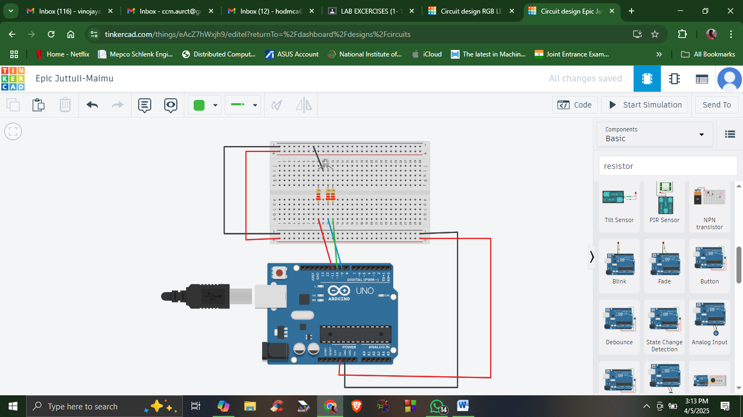

**Blocks**

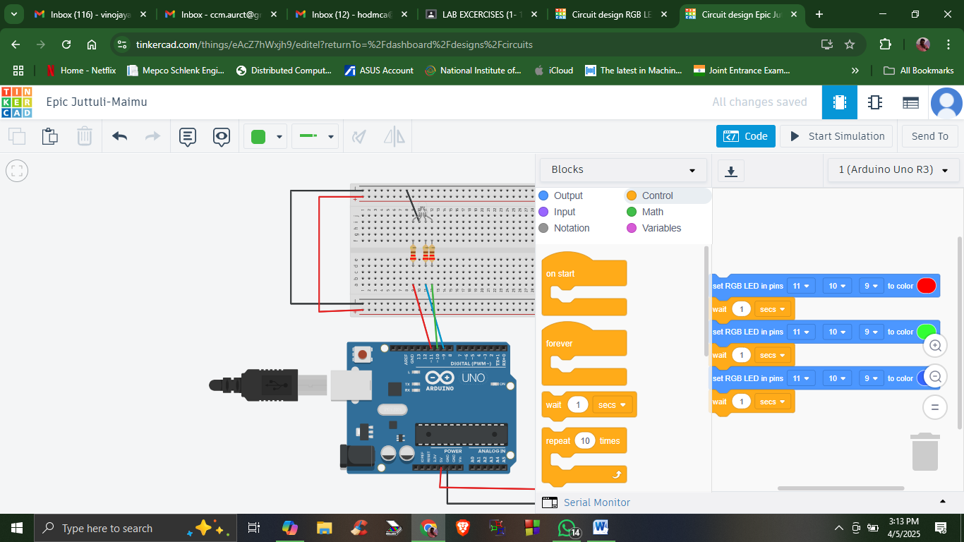

**Blocks + Text**

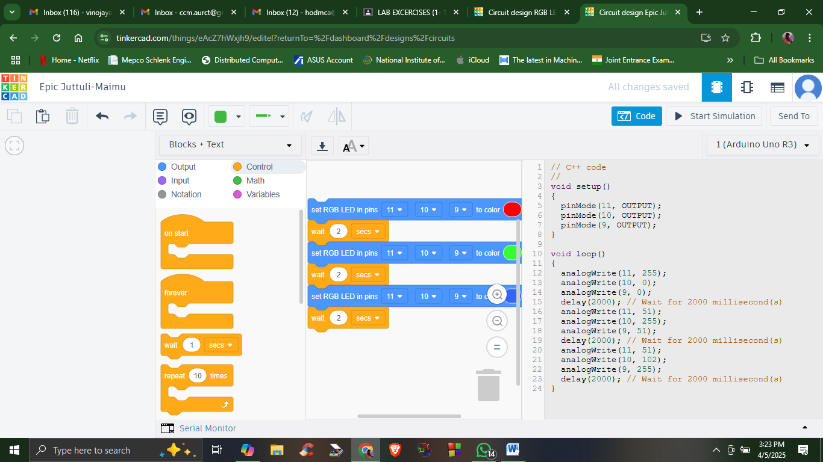

**Output**

